Rising Waters : Machine Learning Based Flood Prediction System

Project Description:
Floods are among the most devastating natural disasters, claiming thousands of lives and displacing millions every year. Despite their recurring nature, the lack of timely and accurate early-warning systems continues to amplify their destructive impact. Conventional forecasting methods often fall short in predicting floods at the right time, leaving authorities and communities with insufficient opportunity to respond.
This project addresses that gap by building a machine learning-powered flood prediction system trained on historical weather data. Using classification algorithms Decision Tree, Random Forest, K-Nearest Neighbours (KNN), and XGBoost the system analyses meteorological features such as annual rainfall, cloud visibility, and seasonal rainfall patterns to predict the likelihood of a flood event.
The best-performing model is saved and integrated into a Flask web application, enabling concerned authorities and disaster management teams to monitor flood risk predictions through an intuitive and accessible user interface. The application is designed for potential deployment on IBM Cloud, making it scalable and accessible from any location.
Scenarios
Scenario 1: Early Flood Warning and Evacuation Planning
A meteorologist enters current rainfall and cloud visibility readings for a flood-prone district. The model analyses the inputs and predicts a high probability of flooding, allowing authorities to issue evacuation advisories several hours in advance.
Scenario 2: Disaster Response and Resource Allocation
A disaster relief coordinator uses the web application during monsoon season to monitor multiple regions simultaneously. By entering regional weather data for each area, the system provides instant flood risk classifications, helping prioritise resource deployment.
Scenario 3: Model Validation and Performance Assessment
A government analyst tests the model against historical flood event data to evaluate its accuracy. The XGBoost model achieves 96.55% accuracy on test data, confirming the system’s reliability for operational use.

Technical Architecture:

Built With
│
▼
+------------------------+
| Flask Web Application |
| Framework |
+------------------------+
▲
│
+---------------------------+ Receives +----------------------+
| AI Flood Prediction |------------->| User Input |
| System | | (Weather Parameters) |
+---------------------------+ +----------------------+
│ │
│ Integrates with │ Receives
└──────────────────────────────────────────┘
▼
+------------------------------+
| Trained ML Model |
| (Decision Tree, Random |
| Forest, KNN, XGBoost) |
+------------------------------+
│
┌────────────────┼──────────────────┐
│ │ │
Predicts Classifies Provides
▼ ▼ ▼
+------------------+ +----------------+ +----------------------+
| Flood Probability| | Risk Level | | Safety Recommendations|
+------------------+ +----------------+ +----------------------+

│
▼
+----------------------------+
| IBM Cloud Deployment |
| (Scalable Web Hosting) |
+----------------------------+

Description:
Labels for the arrows
- AI Flood Prediction System → Flask Web Application → Built With
- AI Flood Prediction System → User Input → Receives
- AI Flood Prediction System → Trained ML Model → Integrates with
- User Input → Trained ML Model → Receives
- Trained ML Model → Flood Probability → Predicts
- Trained ML Model → Risk Level → Classifies
- Trained ML Model → Safety Recommendations → Provides
- Flask Web Application → IBM Cloud Deployment → Deployable on
Pre-requisites:
The essential software, tools, and knowledge required to successfully develop and run the project.
The project was developed using a set of powerful Python-based tools and libraries for data processing, machine learning, visualization, and deployment. These technologies provide the foundation for efficient model development, analysis, and application deployment.
Anaconda Navigator: A desktop graphical user interface used to launch applications and manage Python packages and environments for data science. https://www.anaconda.com/download
PyCharm: An Integrated Development Environment (IDE) specifically designed for Python programming, offering code analysis and debugging tools. https://www.jetbrains.com/pycharm/
NumPy: Core library for numerical computing in Python, providing support for large, multi-dimensional arrays and mathematical functions. https://numpy.org/doc/stable/
Pandas: Data manipulation and analysis library offering data structures and operations for manipulating numerical tables and time series. https://pandas.pydata.org/docs/
Scikit-learn: Machine learning library featuring classification, regression, and clustering algorithms like support vector machines and random forests. https://scikit-learn.org/stable/
Matplotlib: Comprehensive library for creating static, animated, and interactive visualizations in Python. https://matplotlib.org/stable/
Seaborn: Data visualization library based on matplotlib that provides a high-level interface for drawing attractive statistical graphics. https://seaborn.pydata.org/
Flask: A lightweight WSGI web application framework used to build web APIs and deploy machine learning models. https://flask.palletsprojects.com/

Project Workflow:
The project is developed through a structured workflow consisting of multiple epics, covering data collection, analysis, preprocessing, model development, and deployment. Each epic focuses on a specific stage of the machine learning lifecycle to ensure systematic and efficient project execution.
Epic 1: Data Collection
Story 1: Download the flood prediction dataset and load it into the Jupyter Notebook environment for analysis and model development.
Epic 2: Visualizing and Analysing the Data
Story 1: Import all required Python libraries for data manipulation, visualization, and machine learning.
Story 2: Read and explore the dataset to understand its structure, features, and target variable.
Story 3: Perform univariate analysis to study the distribution and characteristics of individual variables.
Story 4: Conduct multivariate analysis to identify relationships and dependencies among multiple features.
Story 5: Perform descriptive statistical analysis to summarize key insights and trends within the dataset.
Epic 3: Data Pre-Processing
Story 1: Identify and handle missing values to improve data quality and consistency.
Story 2: Detect and treat outliers that may negatively impact model performance.
Story 3: Convert categorical variables into numerical representations suitable for machine learning algorithms.
Story 4: Split the dataset into training and testing subsets for model training and evaluation.
Story 5: Apply feature scaling techniques to normalize numerical features and improve model accuracy.
Epic 4: Model Building
Story 1: Train a Decision Tree model and evaluate its ability to predict flood risk.
Story 2: Build and test a Random Forest model to achieve improved prediction performance.
Story 3: Implement a K-Nearest Neighbors (KNN) model and analyze its classification results.
Story 4: Train an XGBoost model and compare its effectiveness against other machine learning models.
Story 5: Compare the performance of all developed models using appropriate evaluation metrics.
Story 6: Select the best-performing model, evaluate its final performance, and save it as a Pickle (.pkl) file for deployment.
Epic 5: Application Building
Story 1: Design and develop HTML pages to create a simple and user-friendly web interface.
Story 2: Build the Flask application and integrate the trained flood prediction model.
Story 3: Run, test, and validate the web application to ensure accurate predictions and proper functionality.
Epic 1 : Data Collection
The flood prediction dataset contains features responsible for predicting flood events, including annual rainfall, cloud visibility, June–September rainfall, and other meteorological variables.
You can collect datasets from popular open-source repositories such as Kaggle, data.gov, and the UCI Machine Learning Repository. For this project, download the dataset from the link below:

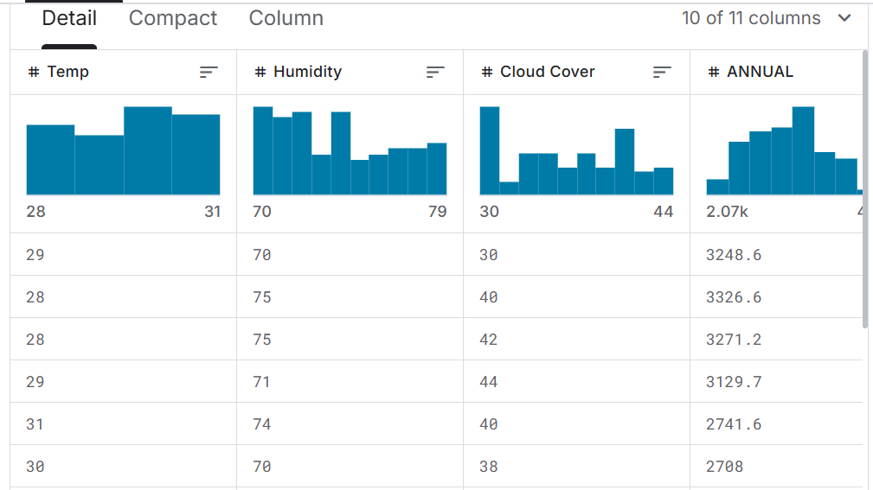

Epic 2 : Visualizing and Analysing the Data

importing Libraries
NumPy & Pandas: Data manipulation and numerical computations.
Matplotlib & Seaborn: Data visualization through charts, plots, and heatmaps.
Scikit-learn: Data preprocessing, model training, and performance evaluation.
XGBoost: Advanced machine learning algorithm for accurate predictions.
Flask: Web application development and model integration.
Joblib/Pickle: Saving and loading trained models for deployment.
These libraries provide the foundation for data analysis, machine learning, and application development. 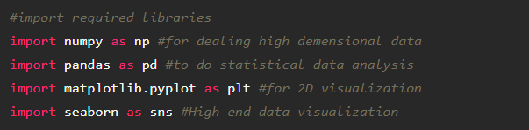

Reading the Dataset:
Loading raw data into the working environment is the foundational step required before any analysis, cleaning, or model training can begin.
Data Loading Functions (Pandas)
CSV: read_csv() (Most common format).
Excel: read_excel().
JSON: read_json().
Text: read_table() or read_csv() with a suitable separator.
Result: Data is converted into a two-dimensional DataFrame for easy manipulation.
Data Exploration Functions
head(): View the initial records to understand data arrangement.
shape: Verify the total number of rows and columns.
info(): Identify column names, data types, and missing (null) values.
describe(): Generate statistical metrics (mean, standard deviation, min/max, percentiles).
Workflow Impact
Accurate loading prevents path and format errors, rendering the data ready for visualization, preprocessing, and model evaluation.

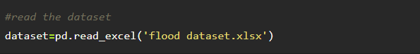

Univariate Analysis:
Univariate analysis examines each dataset feature individually to understand its distribution, frequency, and pattern without cross-comparison. This foundational step clarifies how single variables, both numerical and categorical, behave. It reveals normal distributions, skewness, or imbalances, which directly informs better preprocessing and modeling decisions before applying machine learning algorithms.
Distribution plots:
Distribution plots visualize the spread of numerical data to determine if values follow a normal, skewed, or irregular pattern. By displaying where data points are concentrated, these plots identify the central tendency and shape of features like temperature or rainfall. This understanding guides the selection of appropriate data scaling and preprocessing techniques.
Box plots:
Box plots summarize statistical measures such as the median and quartiles to visualize data spread and pinpoint outliers. Identifying these extreme values is critical because they can severely bias machine learning models and reduce accuracy. Once detected, preprocessing techniques like capping can be applied to replace these outliers with upper or lower boundary values, ensuring robust model training.

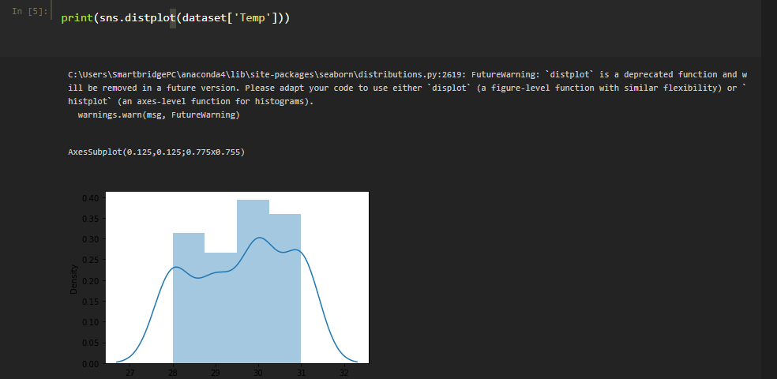

Multivariate Analysis
Multivariate analysis examines relationships among multiple features simultaneously, helping identify patterns and feature dependencies within the dataset. It is useful for selecting relevant features and improving model performance.
Heat Map
.A heat map visualizes correlations between variables using color intensity.
.Strong correlations indicate closely related features, while weak correlations suggest little or no relationship.
It helps identify less significant features that can be removed to reduce complexity and enhance model efficiency.
Overall, heat maps provide valuable insights into feature relationships and support effective feature selection before model training.
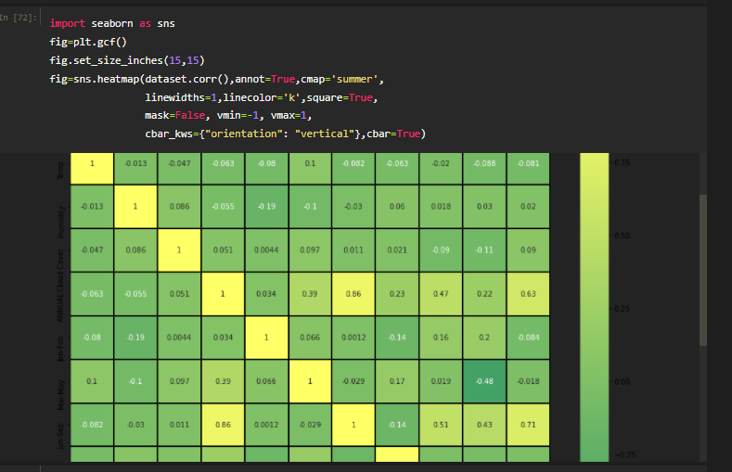
Descriptive Analysis:
head() is used to view the first few records and understand the dataset structure.
info() provides details about columns, data types, and missing values.
describe() generates statistical summaries such as mean,standard deviation, minimum, maximum, and percentiles.
Understanding data types (numeric and categorical) helps determine appropriate preprocessing and analysis techniques.
Workflow Impact: These functions provide a clear overview of the dataset and help identify issues before preprocessing and model development.

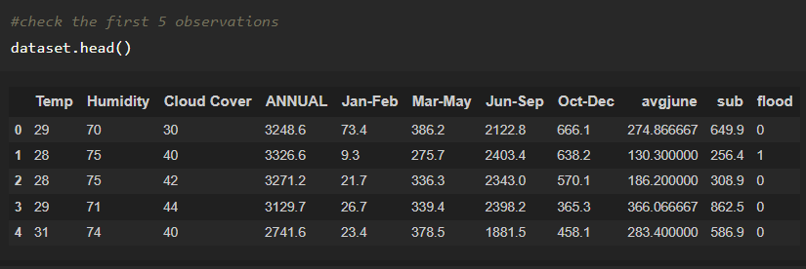

Data Pre-processing
Handling missing values is an essential data preprocessing step because incomplete data compromises machine learning model accuracy and reliability. Missing data occurs when entries are empty or unrecorded, which can cause training errors or incorrect predictions.
To detect missing values, the function isnull().sum() is used. It checks each cell, returning True for missing and False for present, and counts the total missing values per column. The function isnull().any() confirms if any column contains missing data at all.

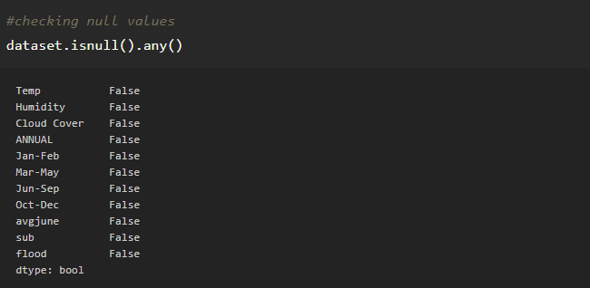
Handling Outliers
Outlier handling is an important preprocessing step because extreme values can negatively affect machine learning model performance. Outliers are identified using box plots and the Interquartile Range (IQR) method, where values outside the calculated upper and lower bounds are considered outliers.
Instead of removing these values, the capping technique is applied to preserve the dataset size. Values above the upper limit are replaced with the upper bound, while values below the lower limit are replaced with the lower bound. In this project, outliers were detected and treated using the IQR-based capping method, ensuring a cleaner dataset and more reliable model performance.

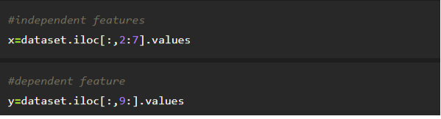
Handling Categorical Values
Categorical features must be converted to numerical format before model training. This project applies feature mapping and label encoding to transform any categorical columns.
Handling Categorical Values
Categorical features must be converted into numerical format before model training because machine learning algorithms work mainly with numbers.
Categorical data contains values in text or category form, such as gender, income type, education type, housing type, family status, weather condition, or status labels.
If these text values are passed directly to a machine learning model, the model may not understand them and may generate errors during training.
Therefore, categorical values are transformed into numerical values using encoding techniques.
In this project, feature mapping and label encoding are used to convert categorical columns into machine-readable format.
Feature Mapping
Feature mapping is used when categories have a clear order or fixed meaning.
In this method, each category is manually assigned a numerical value.
For example:
Low = 0
Medium = 1
High = 2
This makes the data easier for the model to understand.
Feature mapping is useful when the relationship between categories is known.
Label Encoding
Label encoding is another technique used to convert categorical values into numbers.
In label encoding, each unique category is assigned a different integer value.
For example:
Male = 0
Female = 1
Working = 0
Student = 1
Pensioner = 2
This technique is useful when categorical columns contain multiple unique values.
The LabelEncoder class from Scikit-learn can be used for this process.
After applying label encoding, all categorical columns are converted into numerical form.
This allows machine learning algorithms to process the dataset correctly.
Importance of Handling Categorical Values:
Handling categorical values is important because raw text data cannot be directly used for model training.
Encoding improves data compatibility with machine learning algorithms.
It helps convert meaningful categories into structured numerical values.
It also ensures that the dataset is fully prepared for training and testing.
If categorical values are not handled properly, the model may fail to train or may produce inaccurate results.

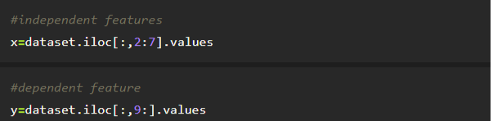
Splitting Data into Training and Test Sets
Core Concept
Splitting the dataset into dependent and independent variables is a critical step before model training. This step completely separates the input data from the output data, allowing the model to learn the relationship between them.
Independent Variables (X):
Independent variables, represented by X, are the input features used by the machine learning model to make predictions. These columns contain the useful information and patterns needed for learning. Only relevant input columns should be selected, especially those highly correlated with the target variable, as they contribute to a more accurate prediction.
Target Variable (y):
The dependent variable, represented by y, is the target variable or output column that the model needs to predict. The class column is assigned to y because it contains the final prediction label. Mathematically, y is treated as a single-column target vector, meaning it contains only one output value for each record in the dataset.
Creating X and y:
A DataFrame X is created by selecting all relevant input columns from the dataset. The class or target column is assigned separately to y. Example: X = dataset.drop('class', axis=1) y = dataset['class']
Importance and Conclusion:
During training, X helps the model understand the specific conditions or features, while y helps the model learn the correct prediction result. Splitting the dataset prepares the data for train-test splitting and model training, allowing the algorithm to learn patterns and generate accurate results.
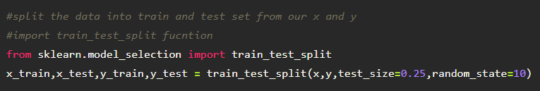
Feature Scaling
. Core Concept Feature scaling is an essential preprocessing step used to bring all input features into a similar range. Without scaling, machine learning algorithms may give more importance to features with larger numerical values, which negatively affects model accuracy and performance.
2. The StandardScaler Mechanism To balance the data, StandardScaler from the scikit-learn library is applied. It transforms data by centering it around the mean and scaling it according to the standard deviation.
- Formula: z = (x - μ) / σ (where x is the original value, μ is the mean, and σ is the standard deviation).
- After transformation, feature values have a mean close to 0 and a standard deviation close to 1, making all inputs perfectly balanced for training.
3. Application Rules Scaling is applied only to the independent variables (X). The target variable (y) is never scaled because it represents a final category or class label (such as Approved or Rejected).
4. Workflow and Deployment
- The scaler is fitted on the training data to learn the metrics, and then used to transform both training and testing data to ensure consistency.
- It is critical to save the fitted scaler using Joblib or Pickle. During real-time prediction, new user input values must be scaled using this exact saved scaler so the model does not receive data in a different format.
5. Key Benefits Feature scaling improves model stability, reduces bias, and is strictly necessary for distance-based or gradient-based algorithms such as KNN, Logistic Regression, and Support Vector Machines.
6. Key Points Summary
- Brings input features into a similar range.
- Uses StandardScaler (Formula: z = (x - μ) / σ).
- Applied only to input features (X), not the target (y).
- The scaler is fitted on training data and reused for testing.
- The scaler must be saved for real-time inference to maintain data consistency.
7. Example Implementation from sklearn.preprocessing import StandardScaler sc = StandardScaler() X_train = sc.fit_transform(X_train) X_test = sc.transform(X_test)
8. Conclusion Feature scaling standardizes numerical features, allowing the model to learn effectively. Saving the fitted scaler guarantees that real-time user inputs are processed exactly like the training data, ensuring consistent and accurate predictions.
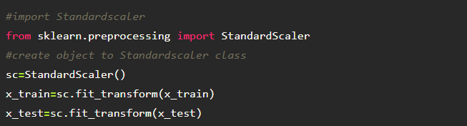
Application Building
Description
This phase focuses on developing the Flask web application and integrating it with the trained prediction model. The system accepts user inputs and provides real-time prediction results through a simple web interface.
Building HTML Pages
Description
The frontend uses Flask's templates/ for HTML pages and static/ for CSS/JS to provide a structured, user-friendly interface for the flood prediction model.
1. templates/ Folder (HTML Pages)
home.html: Landing page explaining the project.
index.html: Input form for weather parameters (sends data to backend).
chance.html: Alert page displayed if a flood is predicted.
no_chance.html: Safe page displayed if no flood is predicted.
2. static/ Folder (Frontend Assets)
main.css: Enhances visual design, layout, and responsiveness.
main.js: Adds interactivity, form validation, and button actions.
Conclusion: Separating HTML files and static assets ensures a well-organized, attractive, and easily manageable application.
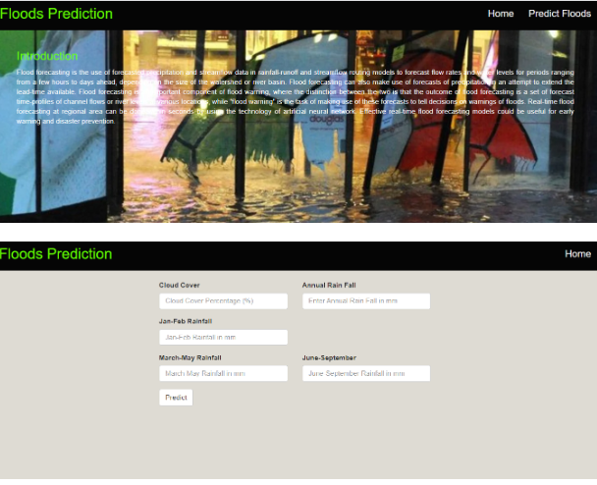
Build the Python Script (app.py):
Setup and Initialization
• Import Dependencies: Load the Flask module and joblib.
• Initialize App: Create the application instance using Flask(name).
• Load Assets: Load the saved model (floods.save) and scaler (transform.save) to process inputs and generate predictions.
Page Routing: URL endpoints are bound to HTML templates using the @app.route() decorator and render_template():
• / routes to home.html (Landing page).
• /Predict routes to index.html (Input form).
• /chance routes to chance.html (Flood predicted).
• /no_chance routes to no_chance.html (No flood predicted).
Prediction Logic
• The predict() function receives weather parameters via a POST request.
• The input values are structured into a DataFrame containing the five independent features.
• The data is passed to the loaded model to generate a prediction, which then redirects the user to the appropriate result page.
Execution
• The application is executed from the main block using app.run(), launching the development server on localhost.

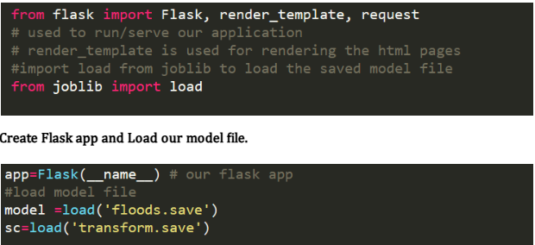
Run the Application
1. Launching the Application
Open Anaconda Prompt.
Navigate to the project directory containing app.py using the command: cd path/to/your/project/folder.
Start the server by executing: python app.py.
2. Accessing the Web Interface
The terminal will generate a local host URL, typically http://127.0.0.1:5000/.
Paste this URL into a web browser to load the application's landing page.
3. User Prediction Workflow
Navigate from the home page to the prediction form by clicking Predict Floods.
Input required weather parameters (e.g., rainfall, temperature, humidity) and click Submit.
4. Backend Processing and Output
· The Flask backend receives the form data, applies the saved StandardScaler to transform the inputs, and passes them to the saved XGBoost model.
· Based on the model's output, the user is instantly redirected to the appropriate result page: chance.html (flood risk) or no_chance.html (safe).

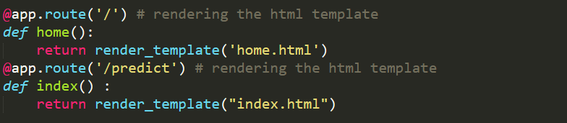
Conclusion
This is the final section of a project report that summarizes the key work completed, highlights the main outcomes and findings, and provides closure to the document by reflecting on the project's overall success and future scope.

